**WE HELP TOGETHER**

**Objective :** To raise funds and support WE HELP TOGETHER in its mission to help each other and distribute the collected of donation amount in very systematic and manner way e.g. donating that amount for flooded area, etc.

**About the project : -**

* We offer robust authentication for our valued donors, guaranteeing a safe and reliable way to contribute to our cause.
* We're here to make a difference when disaster strikes, responding swiftly to floods, accidents, and other crises.
* We're dedicated to the well-being of our fellow humans, ensuring that no one is left behind during their toughest times.

**Project flow/Methodology :**

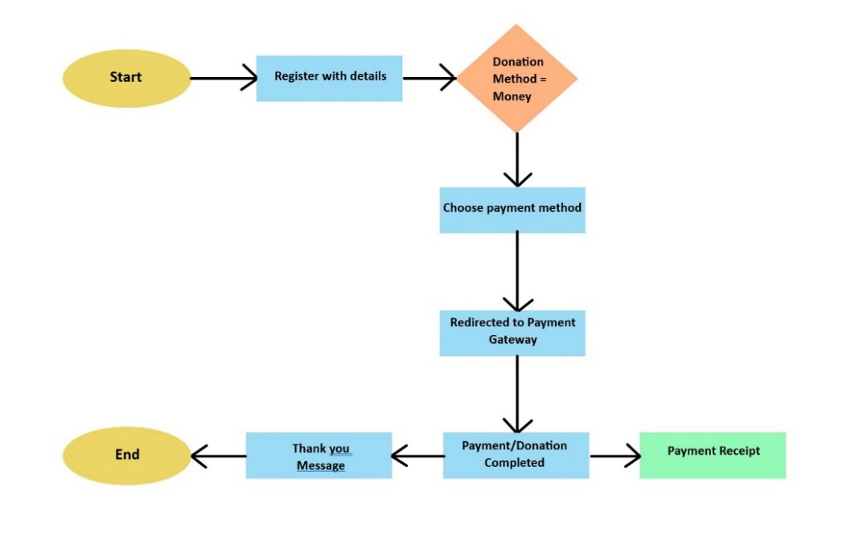

* Users can register with details.
* They have to select donation method which is only money later on we are adding food and clothes options.
* Users have to choose payment method ex-cards,upi,internet banking etc
* If payment done successfully it generates receipt and return thank you message.

**Prakash kumar/ CSE/ 17135**

**Dronacharya Group of Institutions.**

* We are going to introduce a highlight sponsor panel in website to make people more energize to donate.
* We can gain more authenticity by adding a positive review about user experience in website.
* users can humbly seek help and make a life-saving difference by requesting donations. Your generosity can save lives.